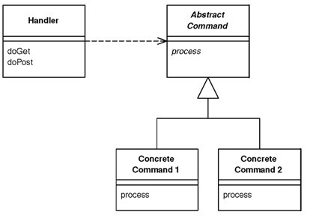



1. **Code à l’intérieur de la classe Handler.cs**



public void ProcessRequest(HttpContext context)

{

FrontCommand command = getCommand(context.Request);

command.Init(context, context.Request, context.Response);

command.Process();

}

private FrontCommand getCommand(HttpRequest request)

{

return (FrontCommand)getCommandClass(request);

}

private object getCommandClass(HttpRequest request)

{

string command = request["command"];

string commandClassName =

System.Configuration.ConfigurationManager.AppSettings[

command];

if (commandClassName != null)

{

Type type = Type.GetType(commandClassName);

if (type != null)

{

return type.GetConstructor(new Type[0]).Invoke(new

Object[0]);

}

}

return new UnknownCommand();

}

public bool IsReusable

{

get

{

return false;

}

}

1. **La classe FrontCommand.cs**

public abstract class FrontCommand

{

protected HttpContext context;

protected HttpRequest request;

protected HttpResponse response;

public void Init(HttpContext context, HttpRequest request, HttpResponse

response)

{

this.context = context;

this.request = request;

this.response = response;

}

abstract public void Process();

// method foward

}

1. **La classe UnknownCommand.cs**

public class UnknownCommand : FrontCommand

{

public override void Process()

{

context.Response.ContentType = "text/plain";

context.Response.Write("Front Controller commande inexistante");

}

}

1. **Dans Web.config**

<appSettings>

<add key="MicroSite" value="FrontControllerExample1.MicroSiteCommand"/>

<add key="MacroSite" value="FrontControllerExample1.MacroSiteCommand"/>

<add key="MicroSiteUrl" value="~/MicroSite.aspx"/>

<add key="MacroSiteUrl" value="~/MacroSite.aspx"/>

</appSettings>

**Dans httpHandlers tag de Web.config, ajouter**

<add verb="GET, POST" path="*/FrontControllerExample1*"

type="FrontControllerExample1.Handler"/>

1. **La classe MicroSiteCommand.cs**

public class MicroSiteCommand : FrontCommand

{

public override void Process()

{

//Redirige vers MicroSite.aspx

context.Server.Transfer(

System.Configuration.ConfigurationManager.AppSettings

["MicroSiteUrl"], true);

}

}

1. **La classe MacroSiteCommand.cs**

public class MacroSiteCommand : FrontCommand

{

public override void Process()

{

//Redirige vers MacroSite.aspx

context.Server.Transfer(

System.Configuration.ConfigurationManager.AppSettings

["MacroSiteUrl"], true);

}

}